

Team 15

Easy C++
Software Design Specification (SDS)
Version: 2
CM Identifier: SDS_easy

Revision History

Sl. No. | Prepared/  Modified by | E-mail | Version | Date | Approved by | Descriptions/  Remarks
1. | Mohamed Talaat | Mohamedtalaat0111790@gmail.com | 1 | 20/3/2018 |  | 5 System Deployment
2. | Khaled sabry | Khaledsab1997@gmail.com | 2 | 22/3/2018 |  | 3.1 Design Patterns Description
3. | Khaled sabry | Khaledsab1997@gmail.com | 3 | 1/4/2018 |  | 3.3 Interaction Diagram
4 | Mohamed Talaat | Mohamedtalaat0111790@gmail.com | 4 | 2/4/2018 |  | 3.2 class diagrams
5 | Khaled sabry | Khaledsab1997@gmail.com | 5 | 4/4/2018 |  | 4 Data Models (ER)
6 | Khaled sabry | Khaledsab1997@gmail.com | 6 | 5/4/2018 |  | 6 Traceability to Requirements
7 | Mohamed Talaat | Mohamedtalaat0111790@gmail.com | 7 | 5/4/2018 |  | 2 System Architecture
8 | Ahmed  Adel | ahmedadel_321@yahoo.com | 8 | 7/4/2018 |  | 1 Introduction
9 | Ahmed Adel | kareemomar96@gmail.com | 9 | 8/4/2018 |  | Revision

Distribution list
Name | E-mail | Notes
Eng. Ali Elseddeek | alielseddeek@gmail.com

Table of Contents

1. Introduction 6
1.1 Purpose of this Document 6
1.2 Scope 6
1.3 Table of Acronyms and Definitions 6
1.3.1 Definition 6
1.4 References 6
1.5 Overview of Document 7
2. System Architecture 8
3. Design Models 9
3.1 Design Patterns Description 9
3.1.1 Design Pattern 1 9
3.1.2 Design Pattern 2 9
3.2 Class Diagrams 9
3.3 Interaction Diagrams 14
4. Data Models 29
5. System Deployment 30
6. Traceability to Requirements 30

List of Figures

Figure 1 - System Architecture
Figure 2 - Controllers
Figure 3 - Views
Figure 4 - Models
Figure 5- Model-Controller
Figure 6 - Views-Controller
Figure 7-Sign Up
Figure 8-Sign In
Figure 9-Forget my password / username
Figure 10-Change Username
Figure 11-Change Password
Figure 12-Change email
Figure 13-Accept request to become instructor
Figure 14-Deny Request to become instructor
Figure 15-Put opinion
Figure 16-Get favorite opinions
Figure 17-Get all opinions
Figure 18-Make opinion as read
Figure 19-Put opinion as favorite or remove it from favorite opinions
Figure 20-Open topics for specific category
Figure 21-Open topic
Figure 22-ER-Diagram

Introduction
This SDS will cover the software easy c++.
Easy c++ will be a tool to help students to understand the concepts of the c++ programming language and provide a community to the students and their instructors.

Purpose of this Document
This Software Design Specification (SDS) exists to establish a baseline for the technical design of easy c++ app.
This document is primarily a blueprint for Team 15 to use in implementing the project.

Scope
Easy C++ is an educational android app used for explaining programming concepts in C++ language. In it you can take lessons at your own pace, test your knowledge in its quizzes, interact with fellow learners and ask instructors for help, there is discussion room where you could put your question or see other’s questions and see the replies or you can put your reply if you know the answer.
After you get to the last level you can apply to become an instructor.

Table of Acronyms and Definitions

Term | Definition
SRS | software requirements specification

References

- “Software Engineering”, 10th Edition, Ian Sommerville.
- www.SmartDraw.com
- “Mastering UML with Rational Rose 2002”, Wendy Boggs, Michael Boggs, SYBEX, 2002.
- “Design Patterns Explained Simply”, Alexander shvits.

Overview of Document

This document consists of several sections all to demonstrate the design and structure of
The app.

- Architectural Design

Architectural design describes the hardware, software, and their interplay within the easy c++ application.
The architectural design of easy c++ will include the communication between the data models, logic controller and interface.

- Class Diagrams

class diagrams describe how the classes connected to each other.

- Interaction Diagrams

Describe how the system will work according to user interaction.

- Entity relationship diagram

illustrate the logical structure of databases.

System Architecture
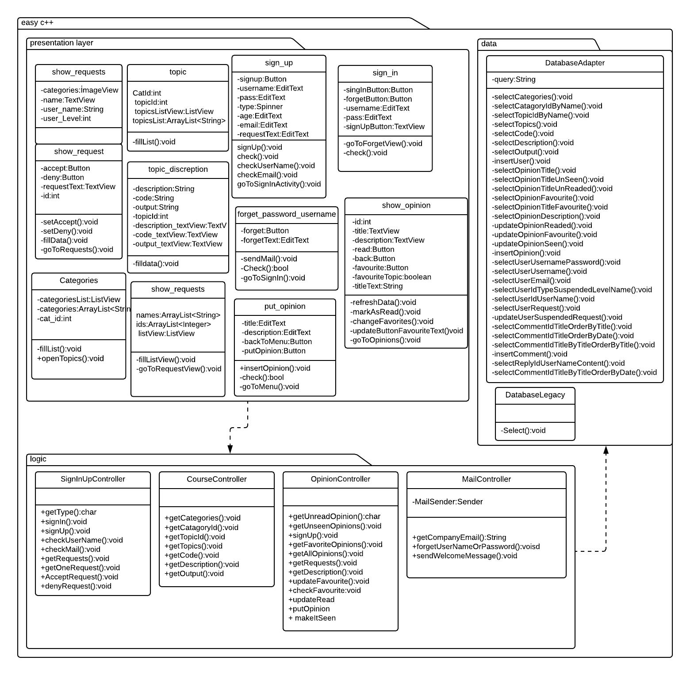
Figure 1 – System Architecture

Design Models

Design Patterns Description

Design Pattern 1
Name: Singleton.
Location : ConnectionDb.
Reason: to have only a single connection with the database for the whole application.

Name: Singleton.
Location: User-Data.
Reason: to have only one user date while the app is running.

Design Pattern 2
Name: Adapter.
Location: Database-Adapter.
Reason: the database Legacy can do (insert, update, delete, select) with the database but what if we want to insert into specific table so in Database-Adapter we handle the query and then send it to the Database-Legacy to handle the query.

Class Diagrams
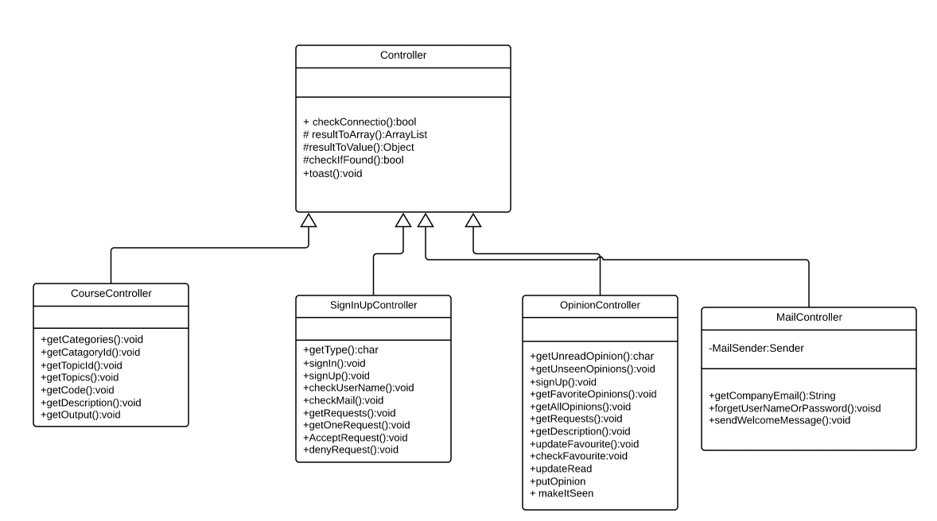
Figure 2 – Controllers
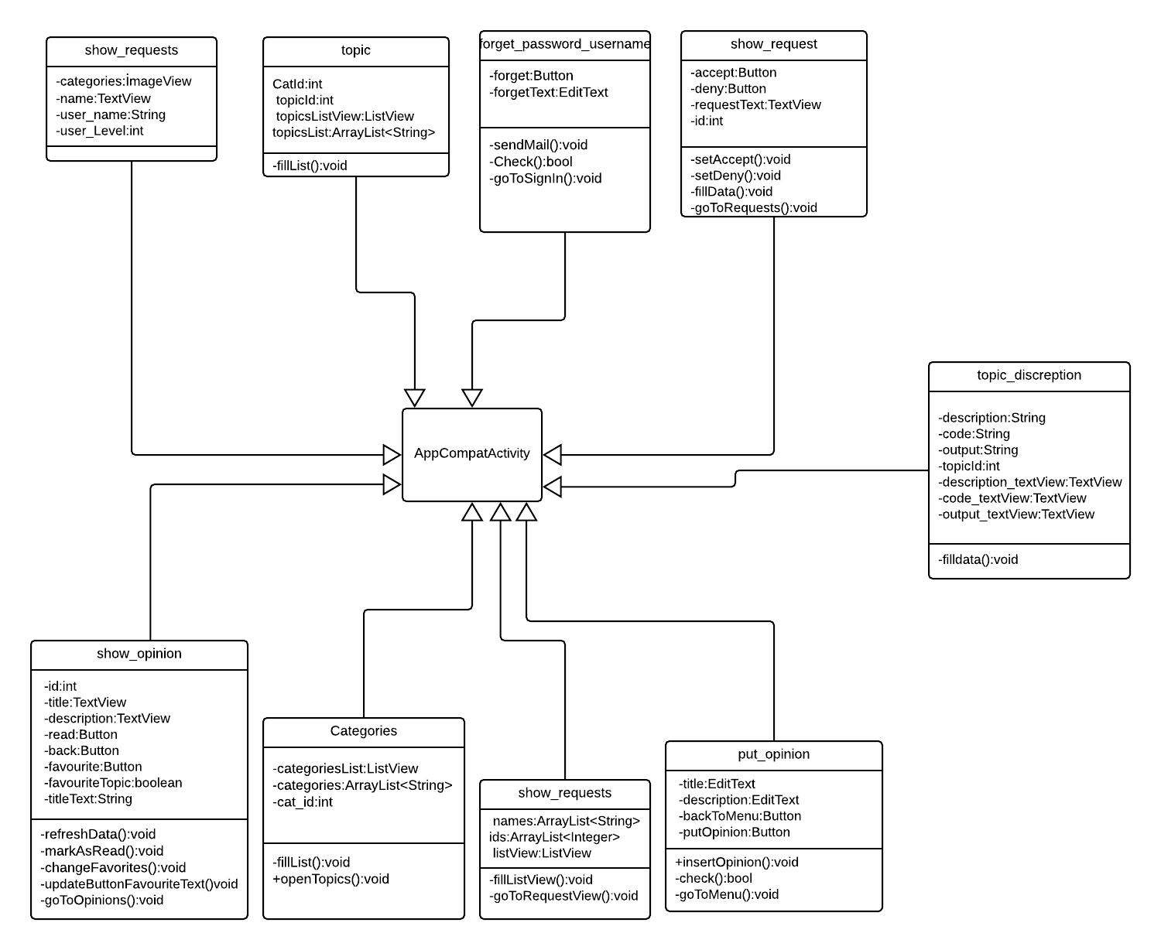
Figure 3 – Views
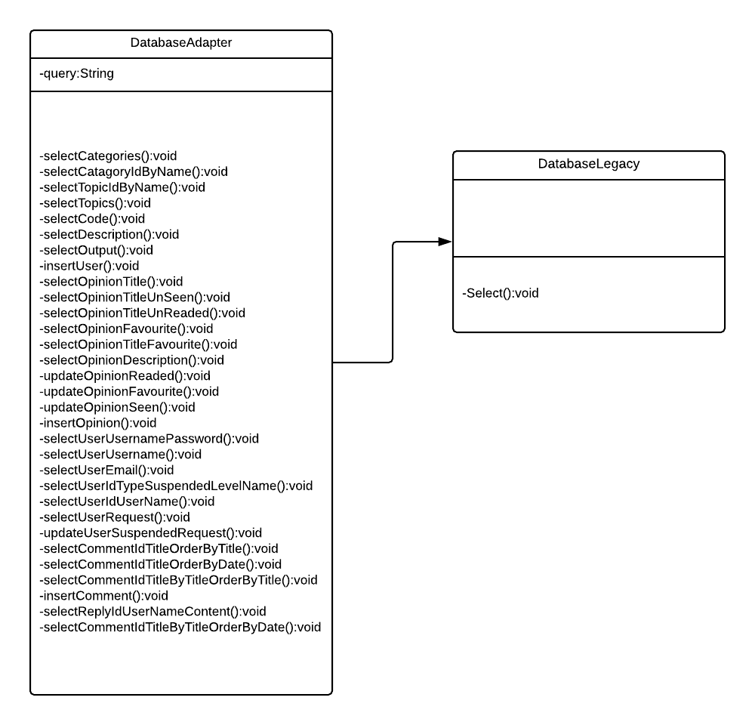

Figure 4 – Models
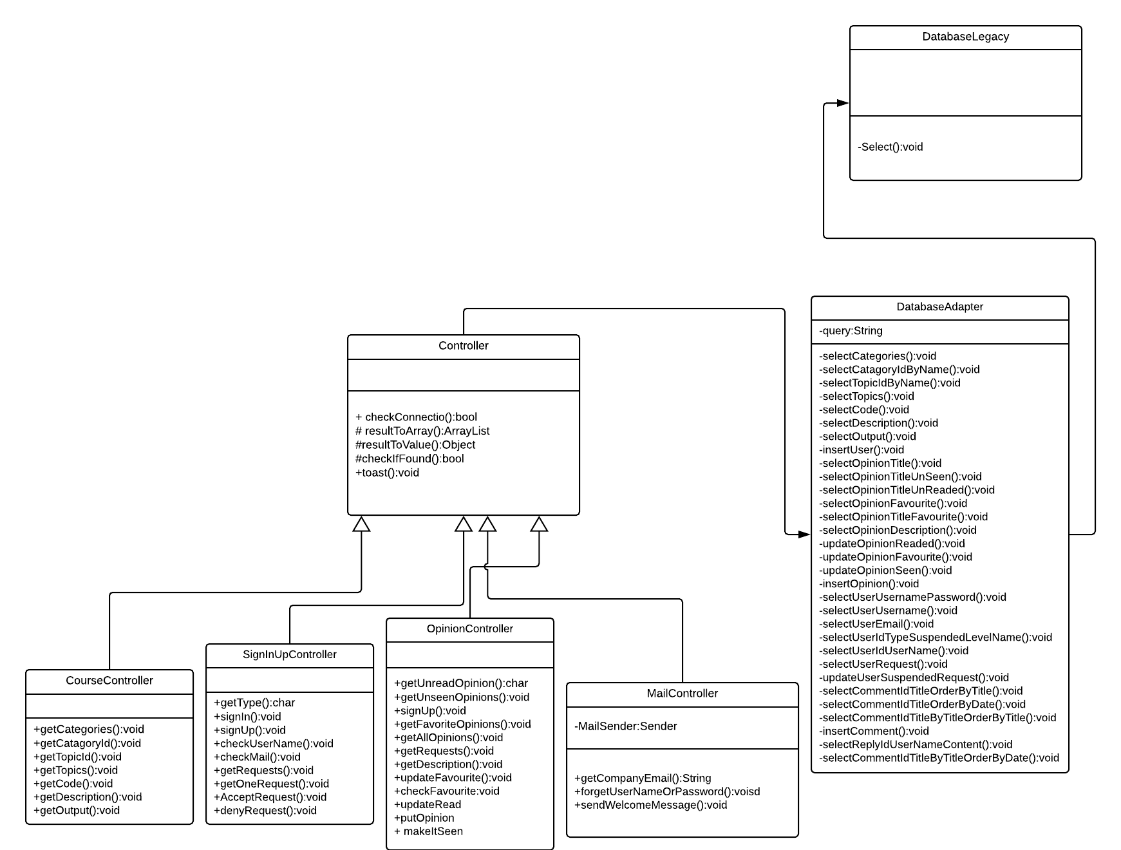
Figure 5– Model-Controller
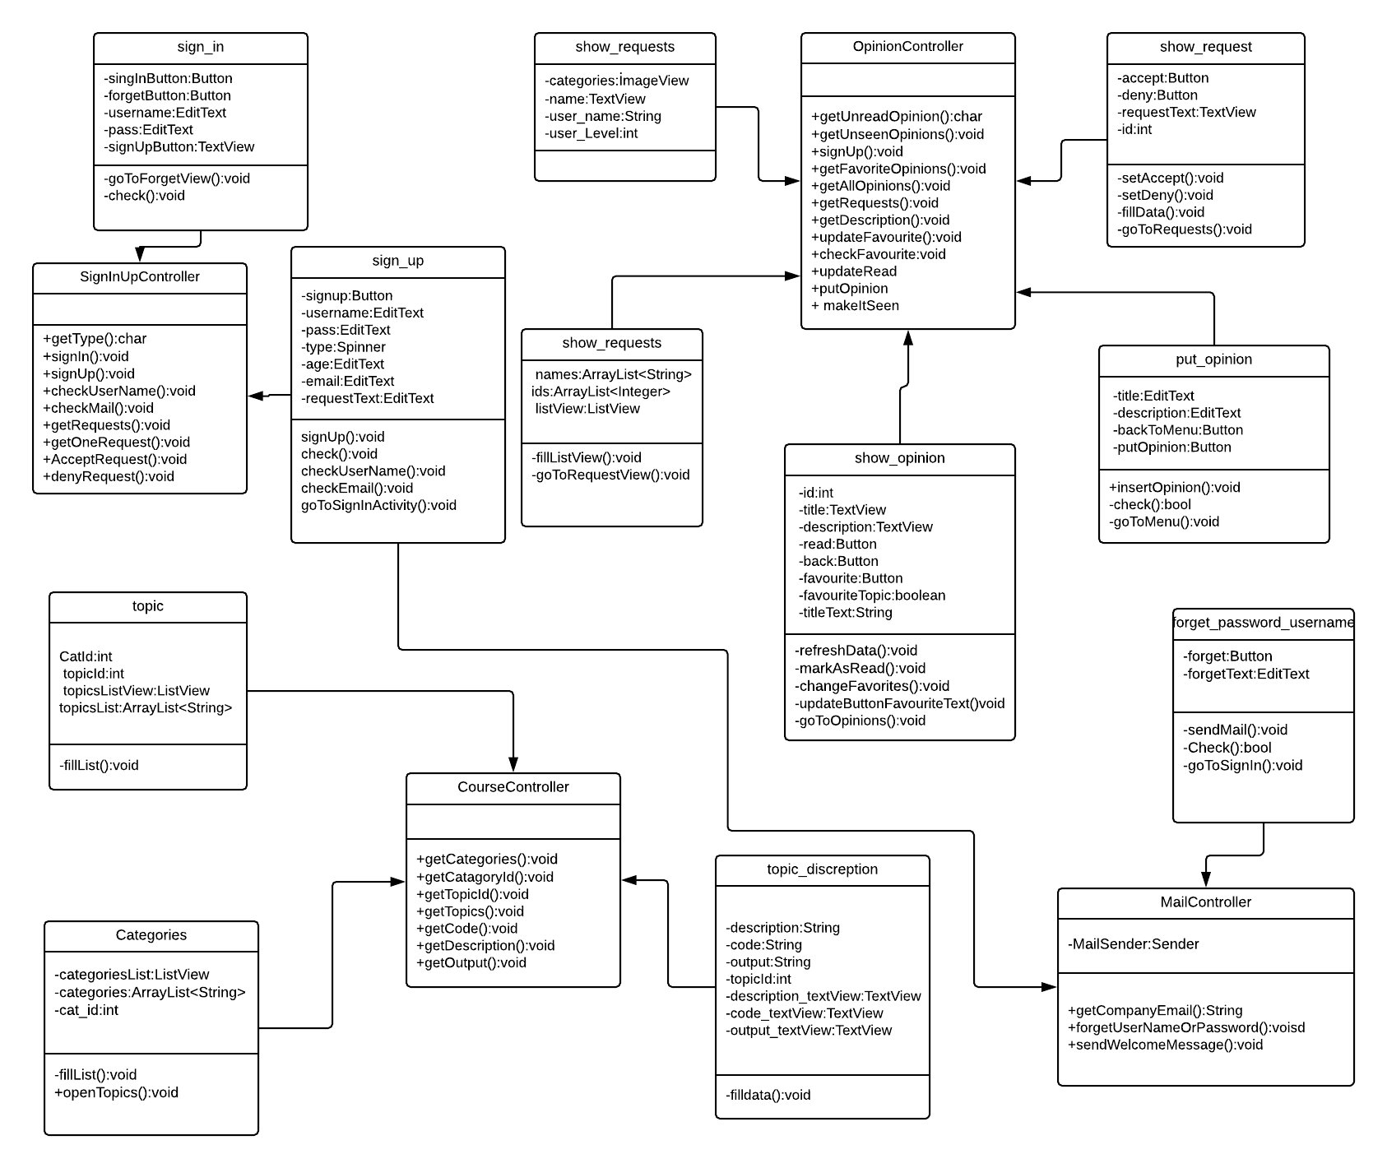
Figure 6 – Views-Controller

Interaction Diagrams
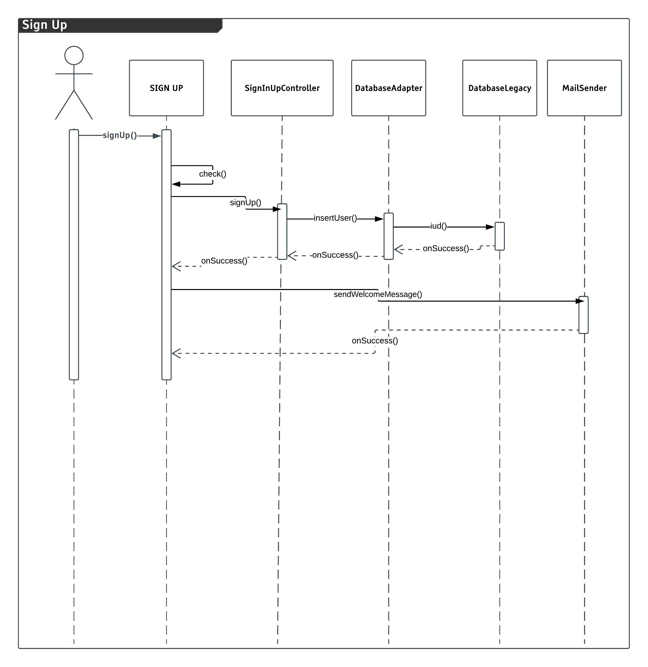

3.3.1 Sign Up

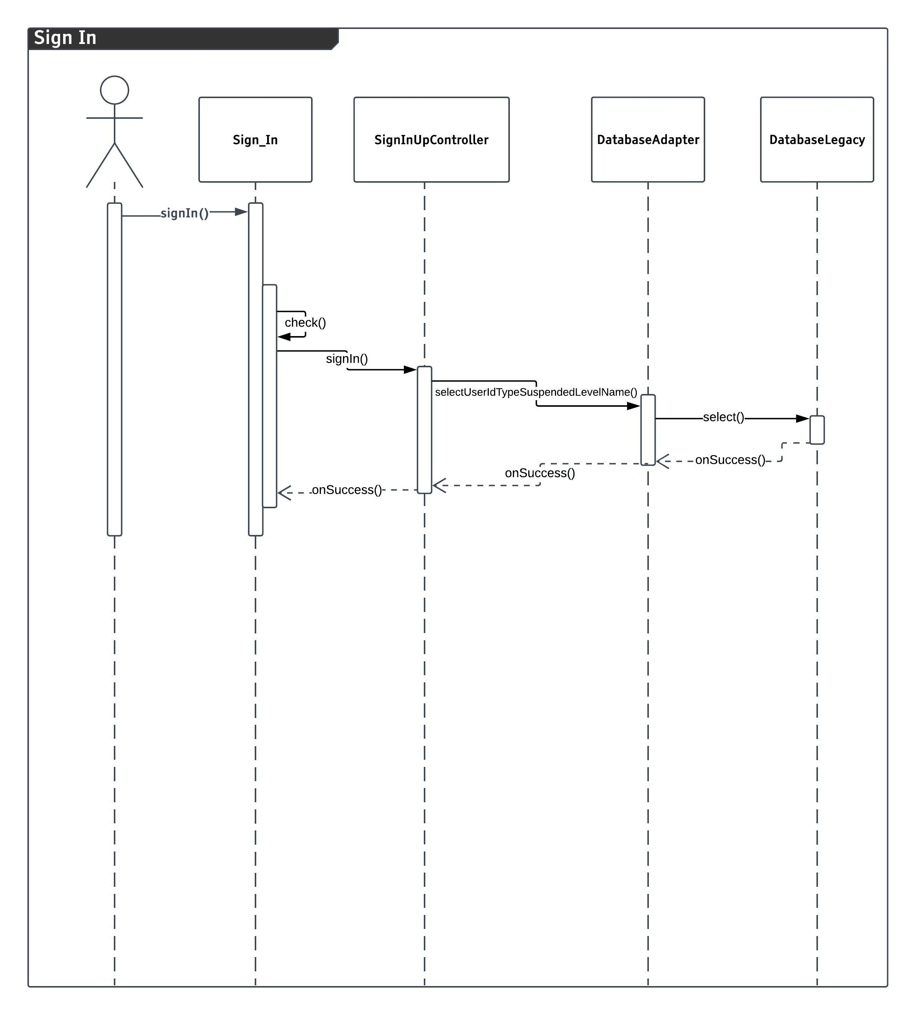
3.3.2 Sign In

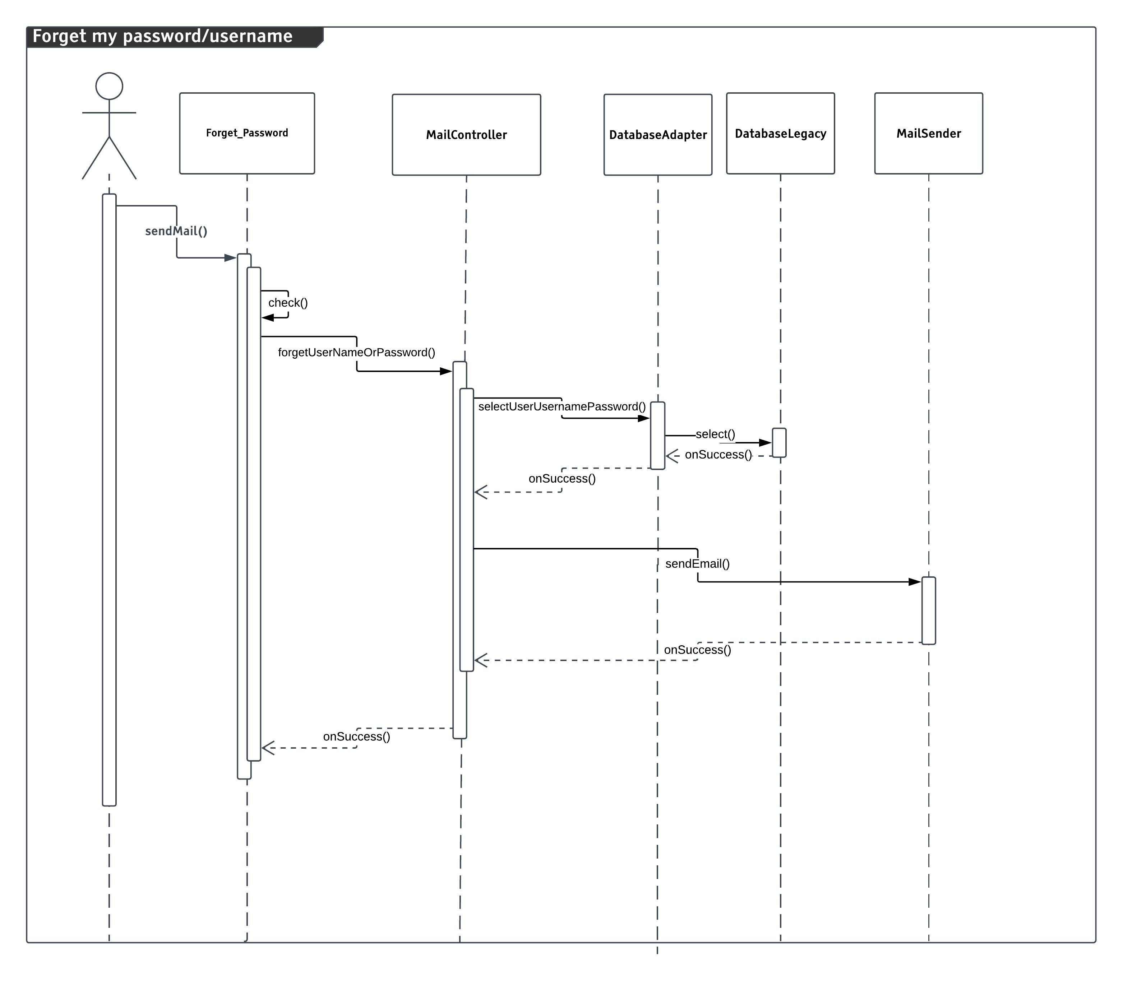
3.3.3 Forget my password / username

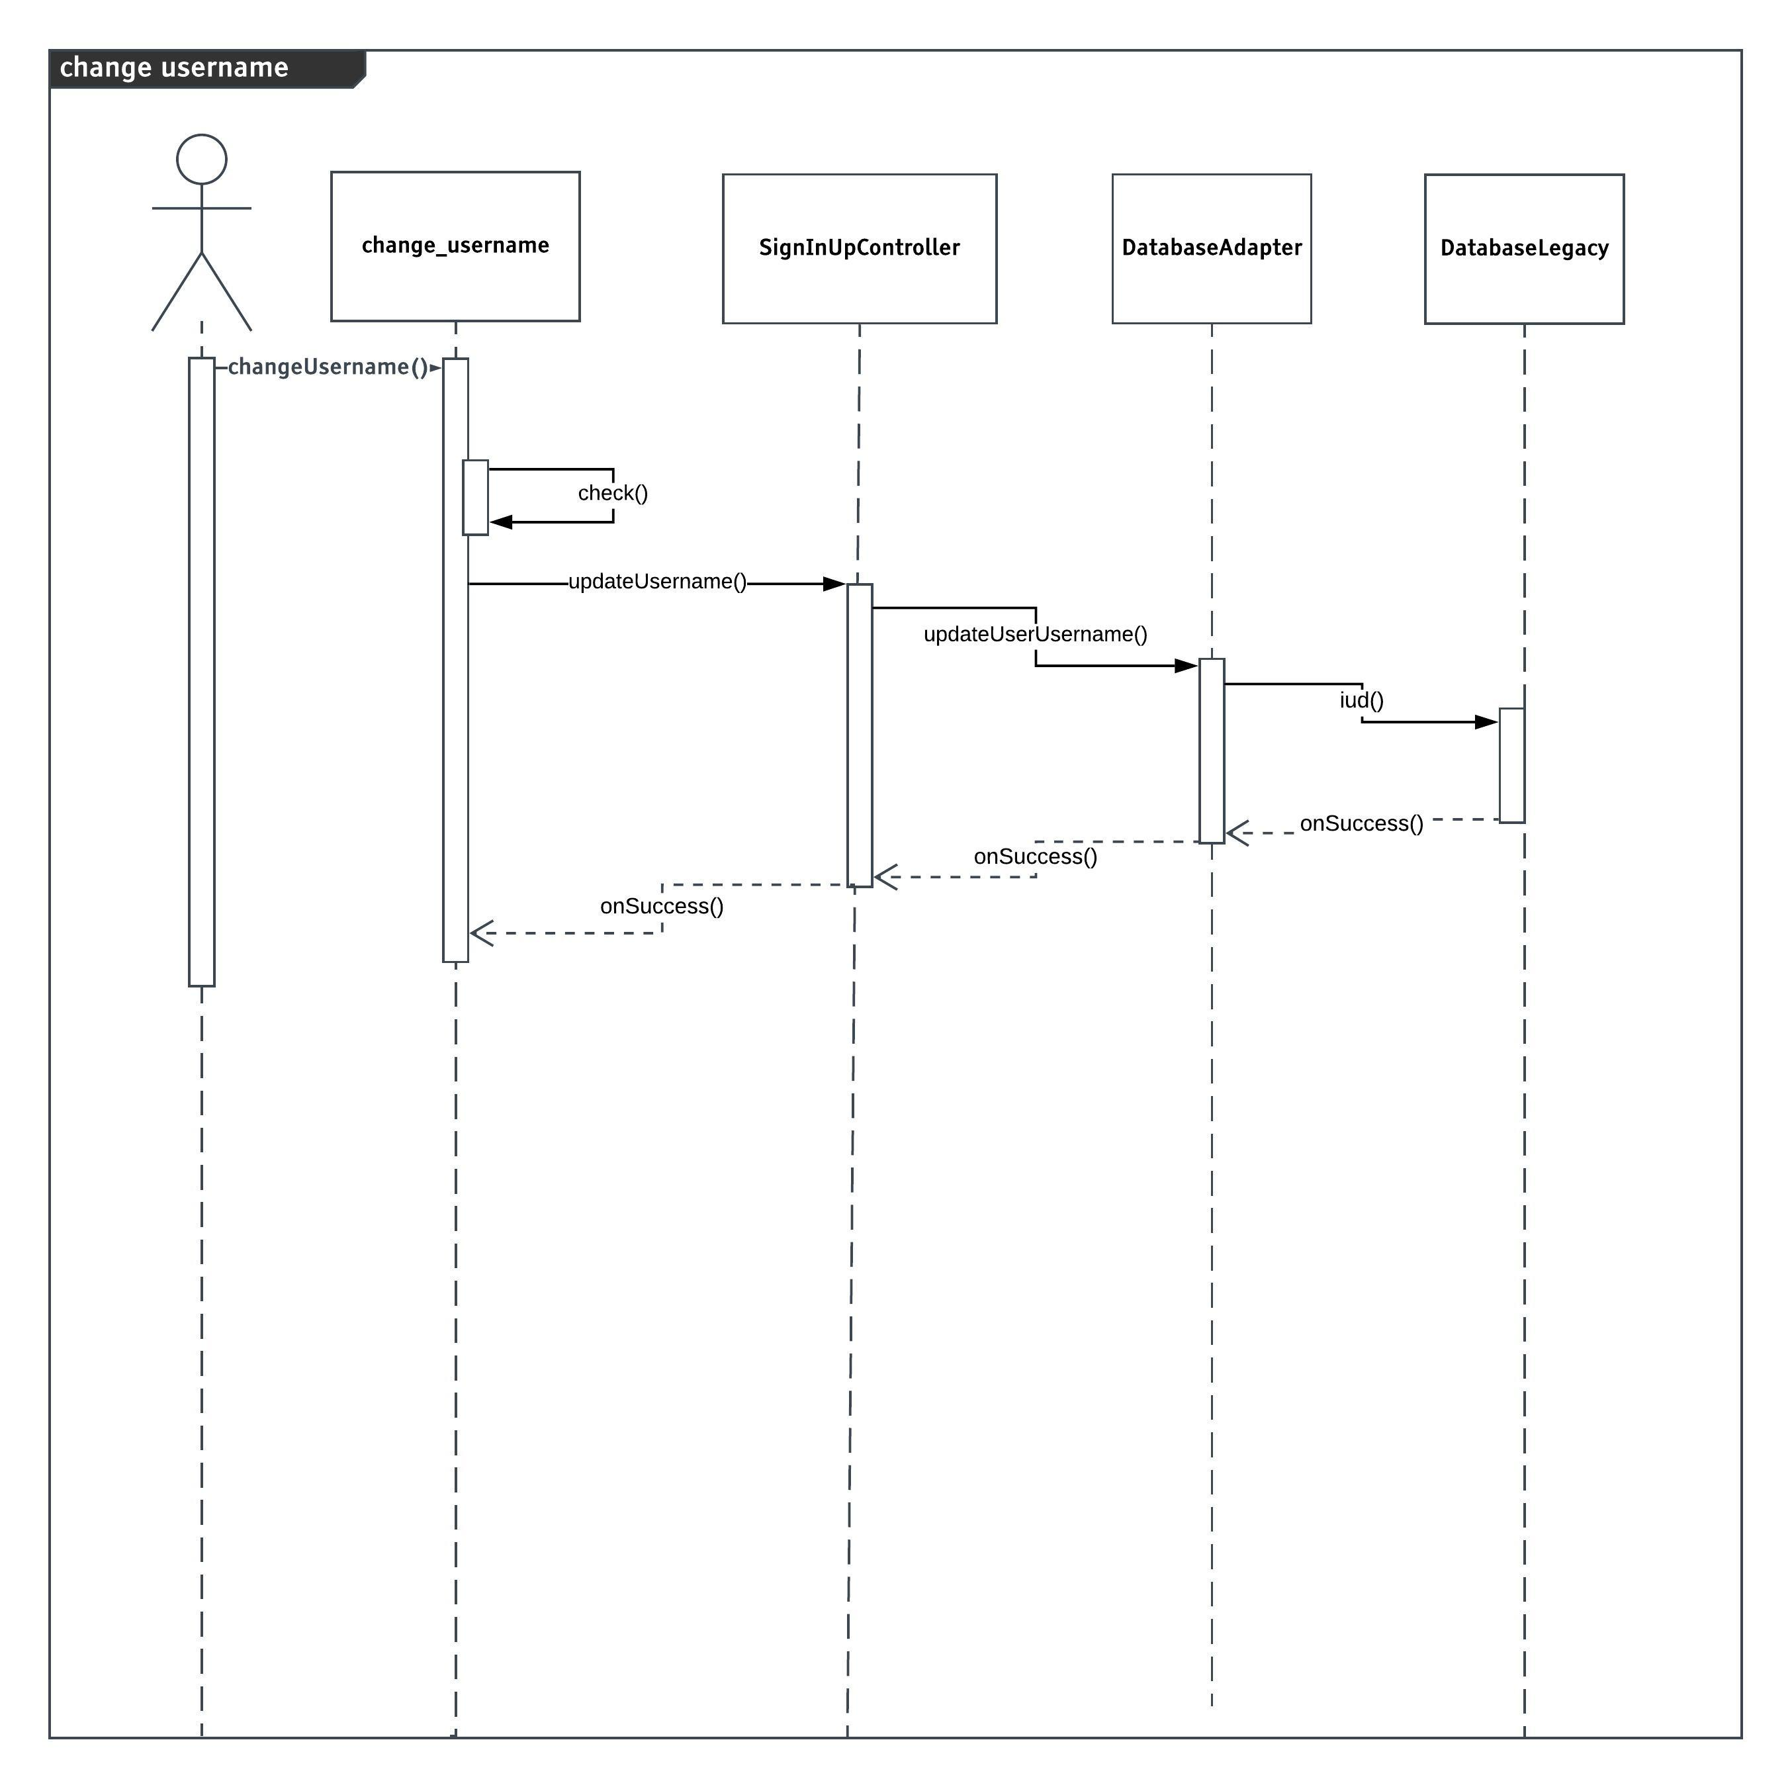 3.3.4 Change Username

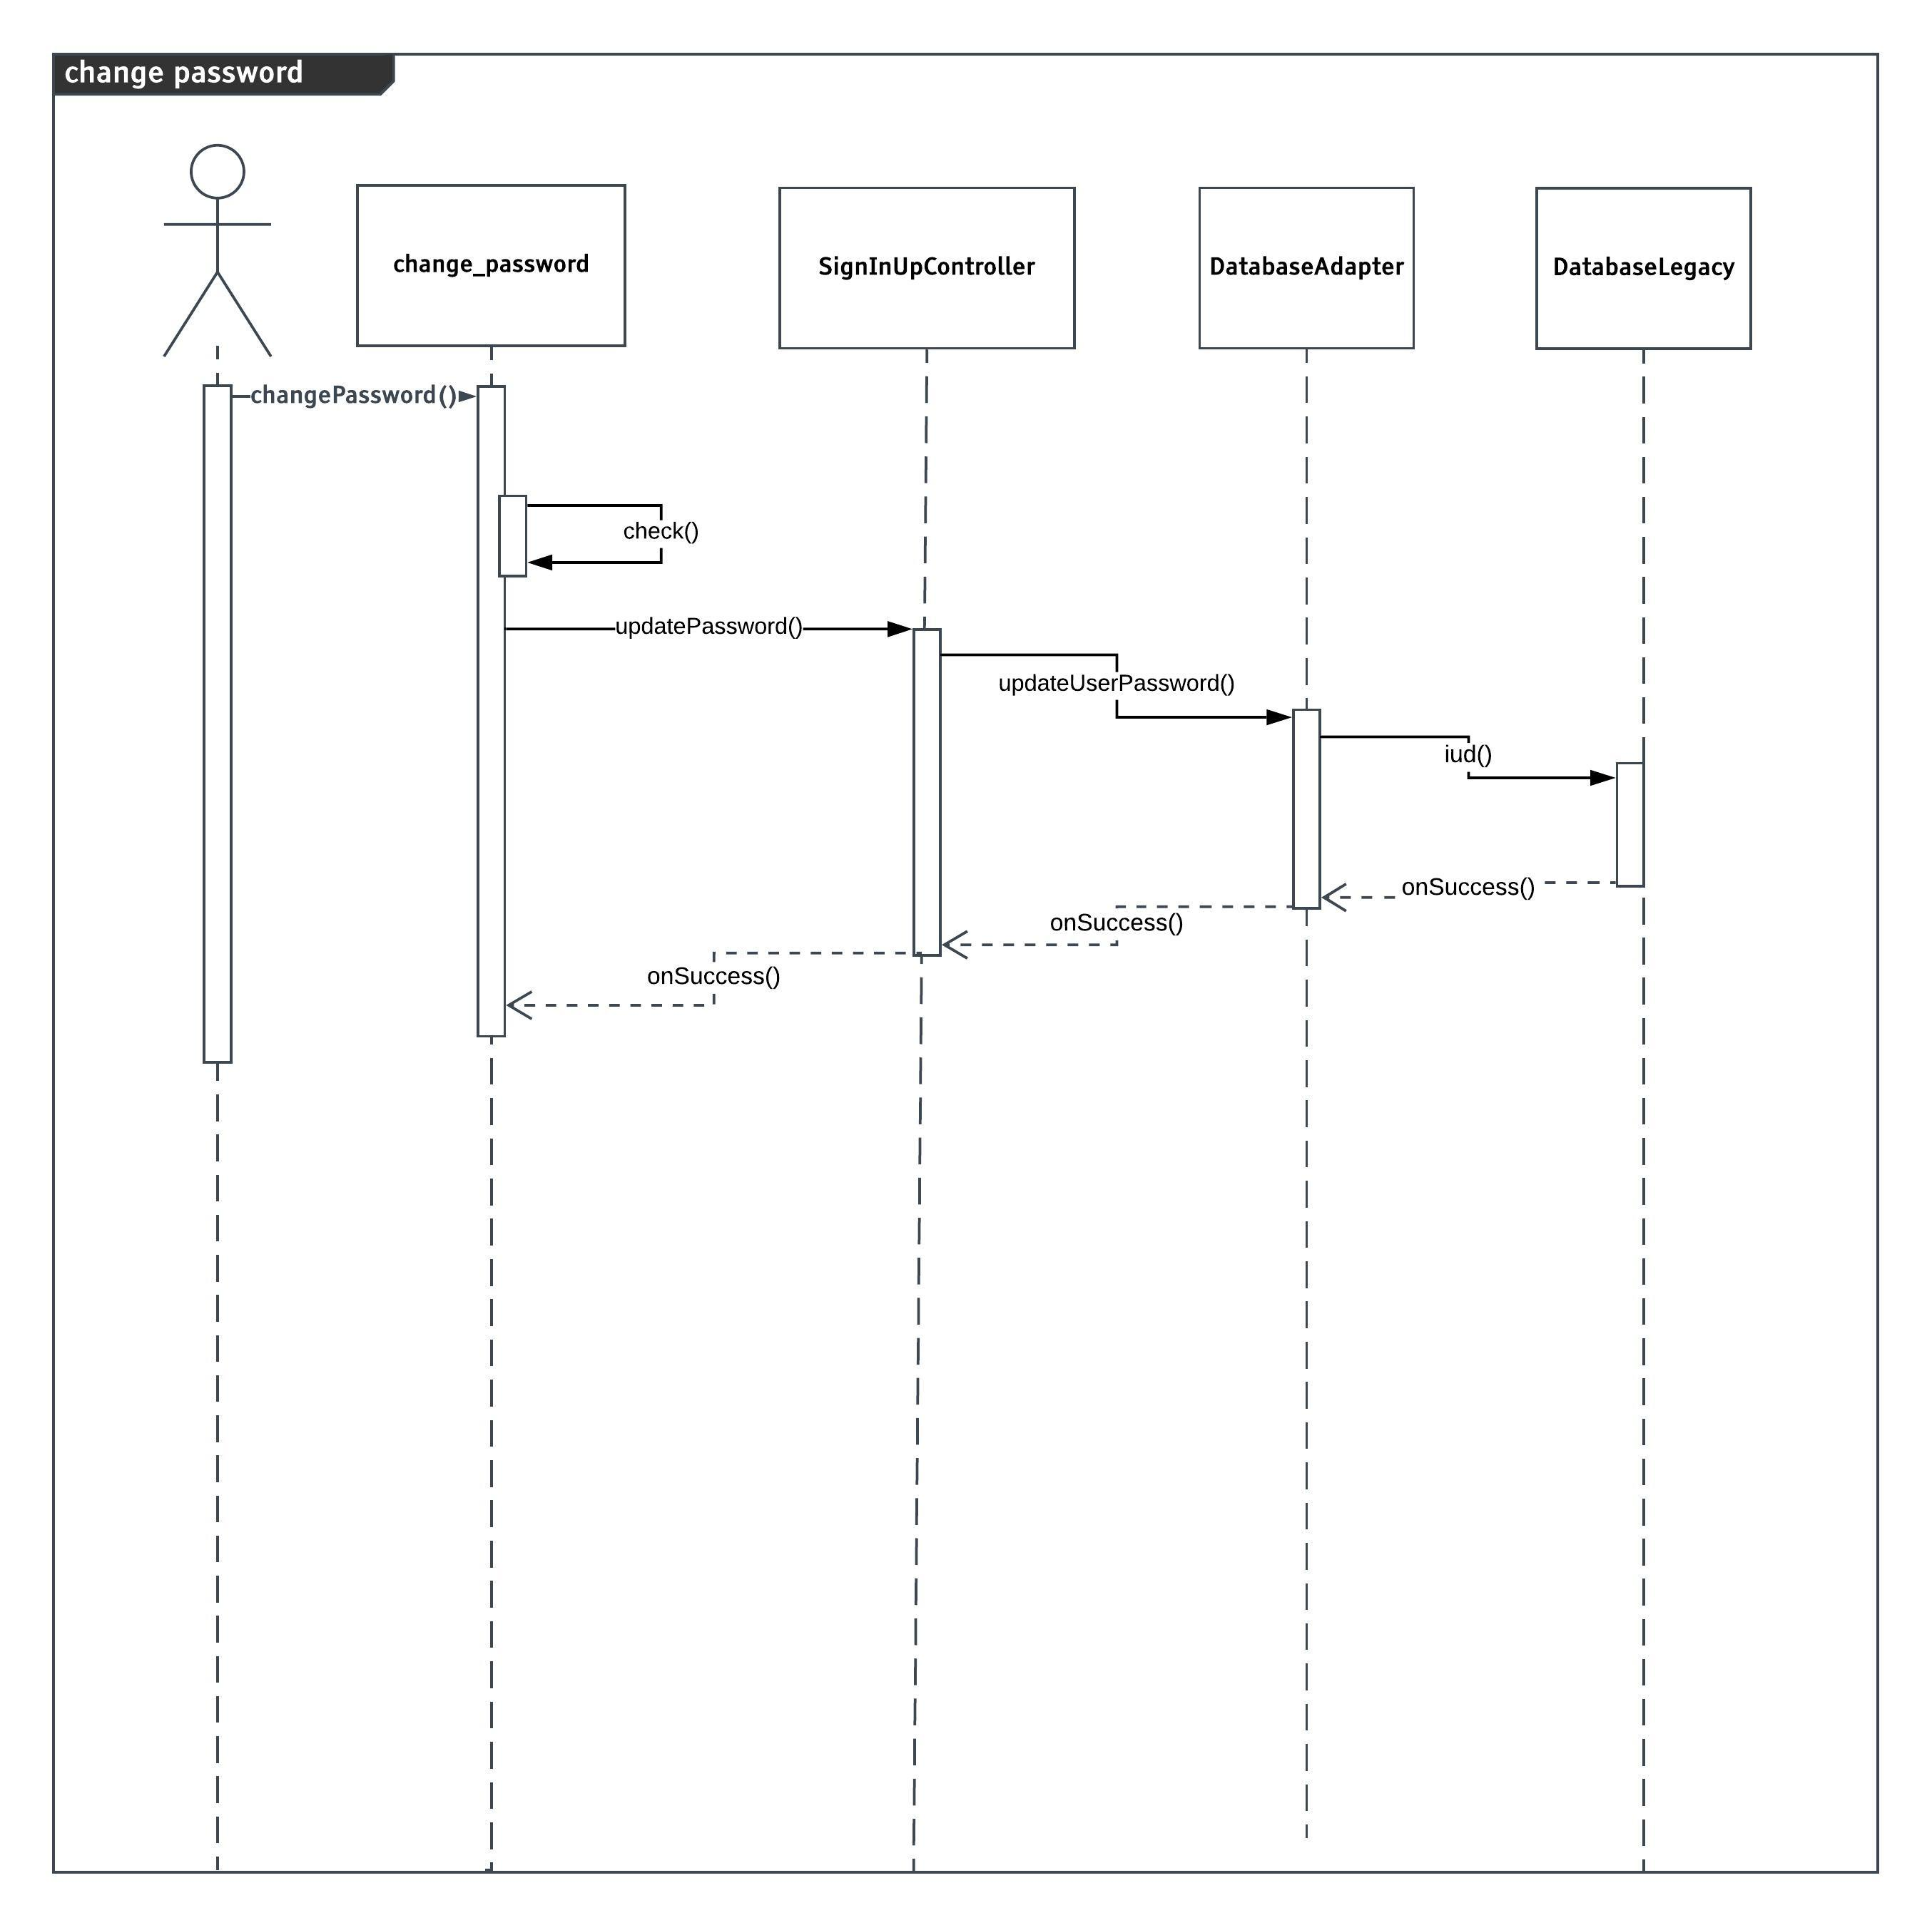
3.3.5 Change Password

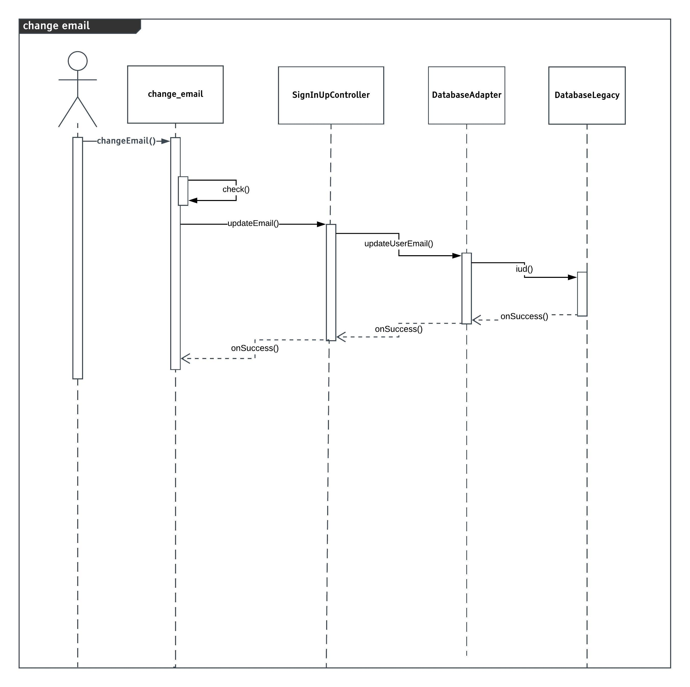
3.3.6 Change email

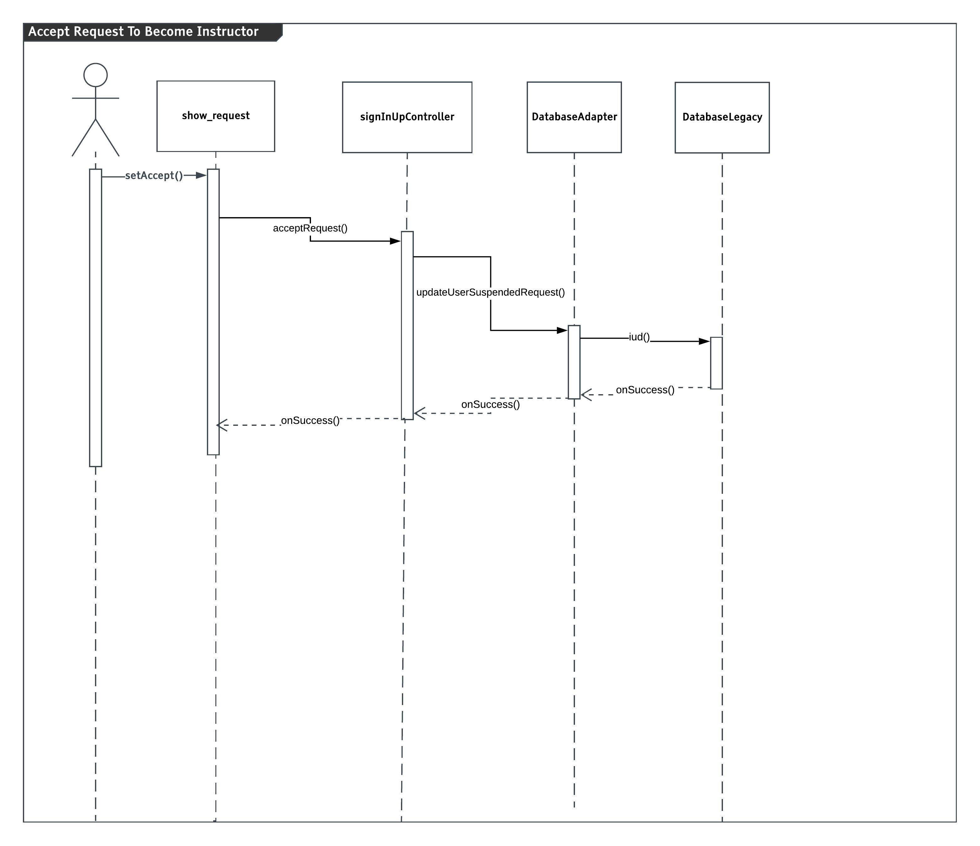
3.3.7 Accept request to become instructor

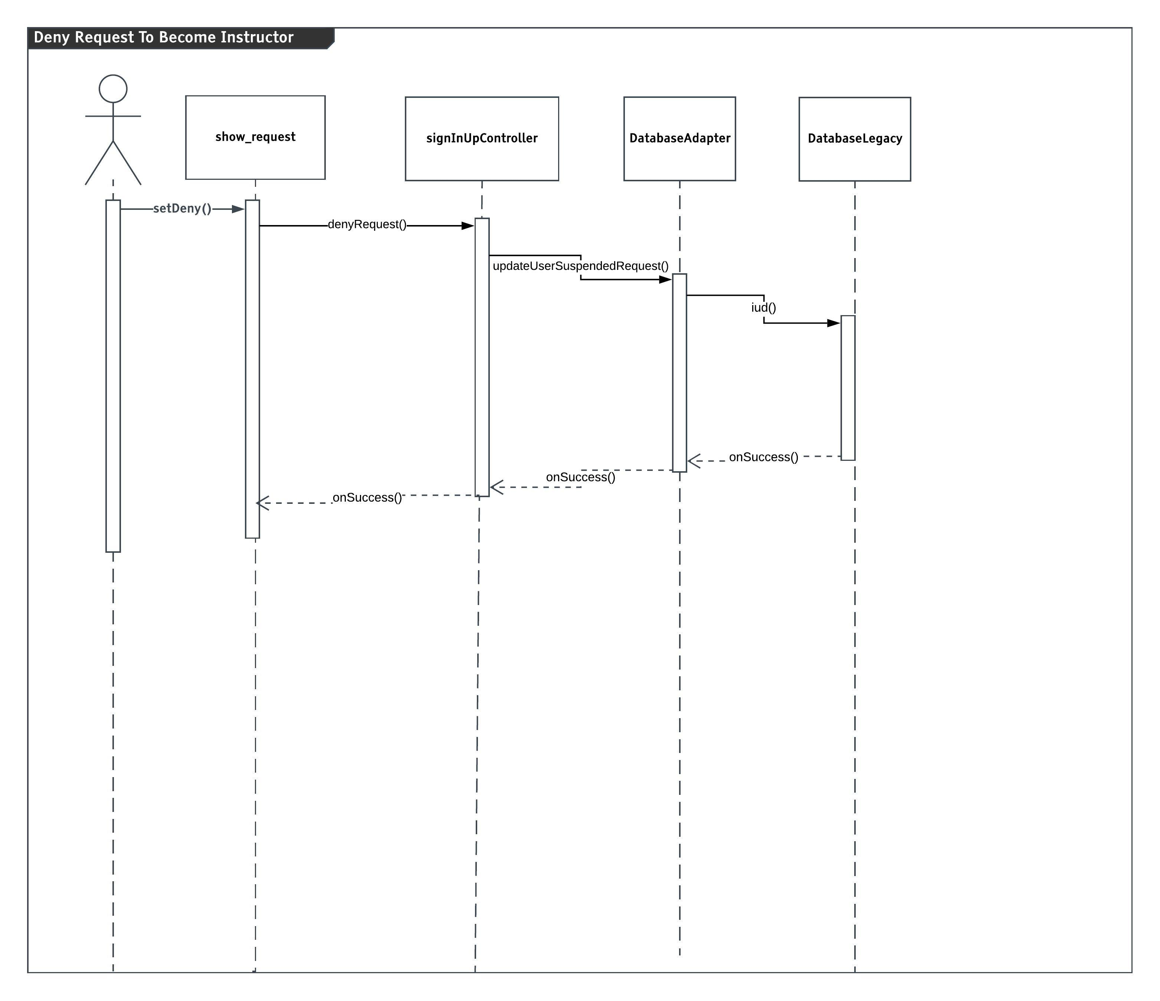
3.3.8 Deny Request to become instructor

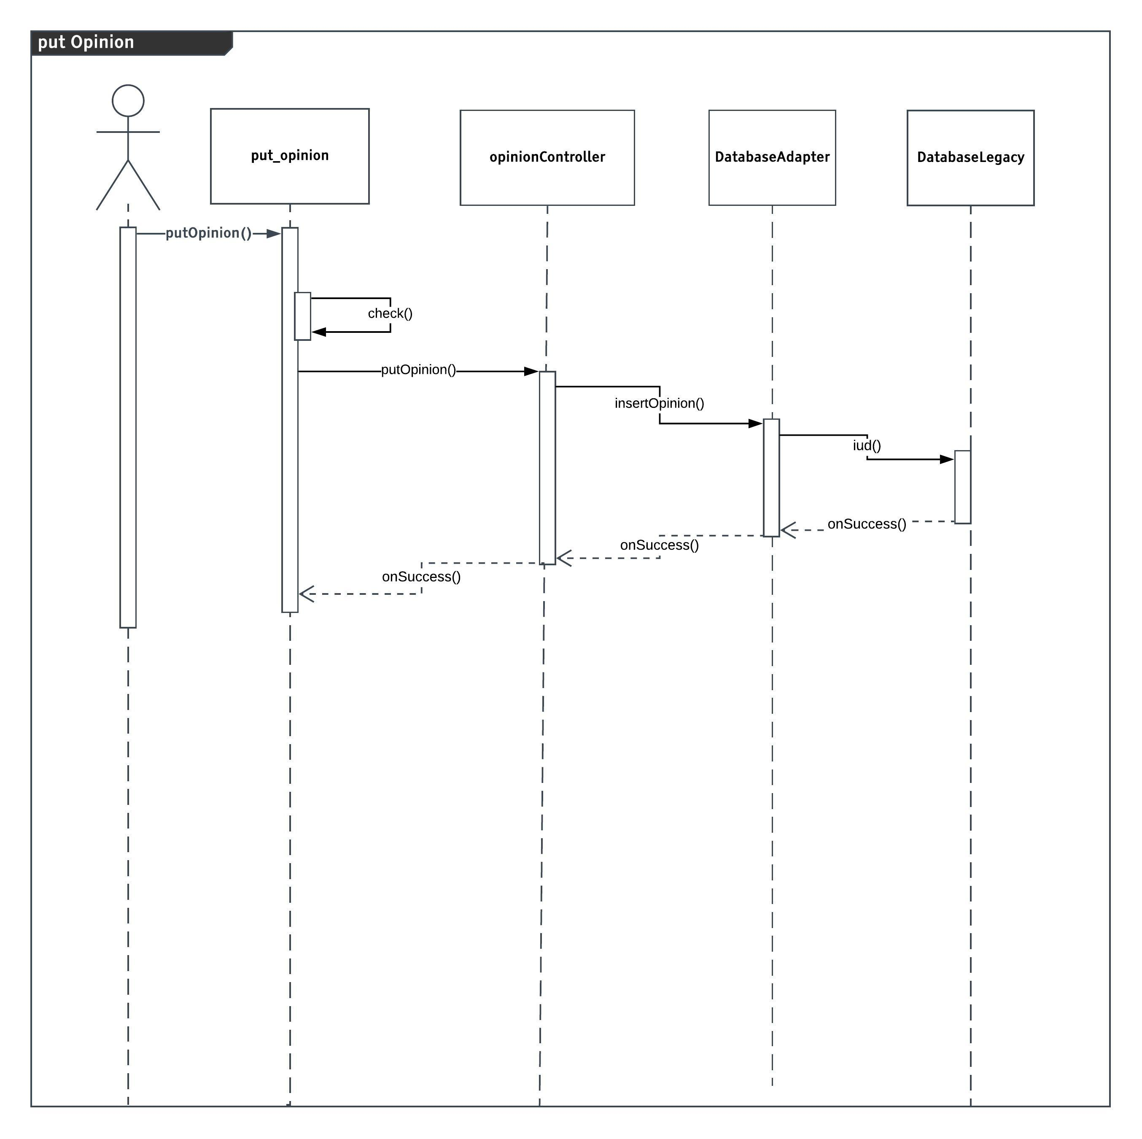
3.3.9 Put opinion

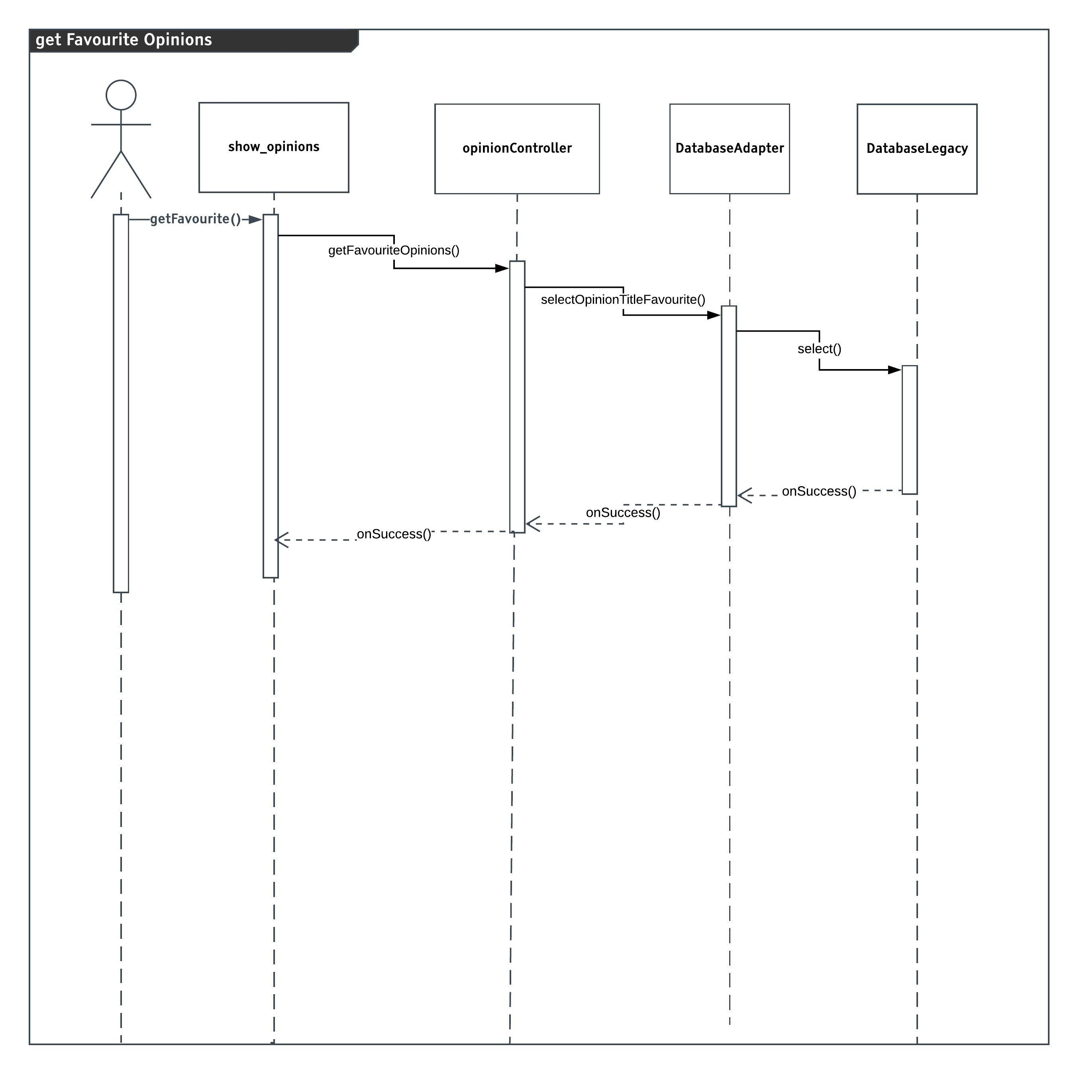
3.3.10 Get favorite opinions

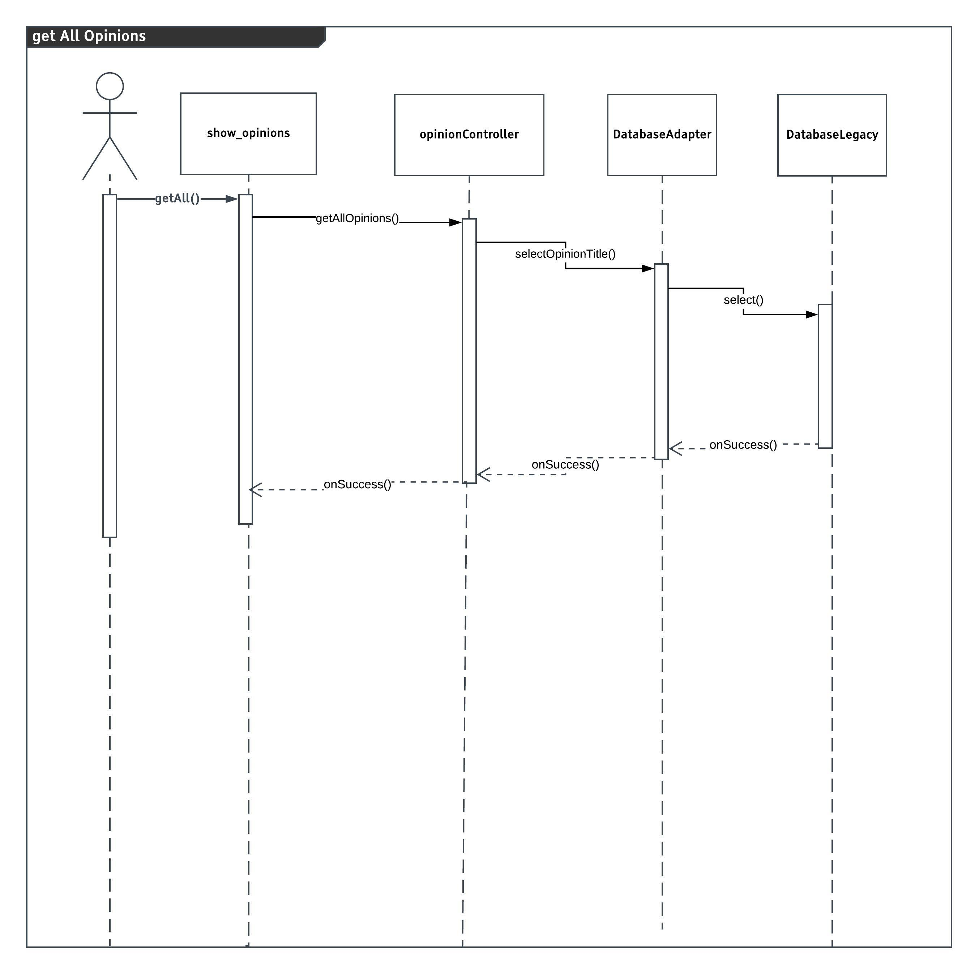
3.3.11 Get all opinions

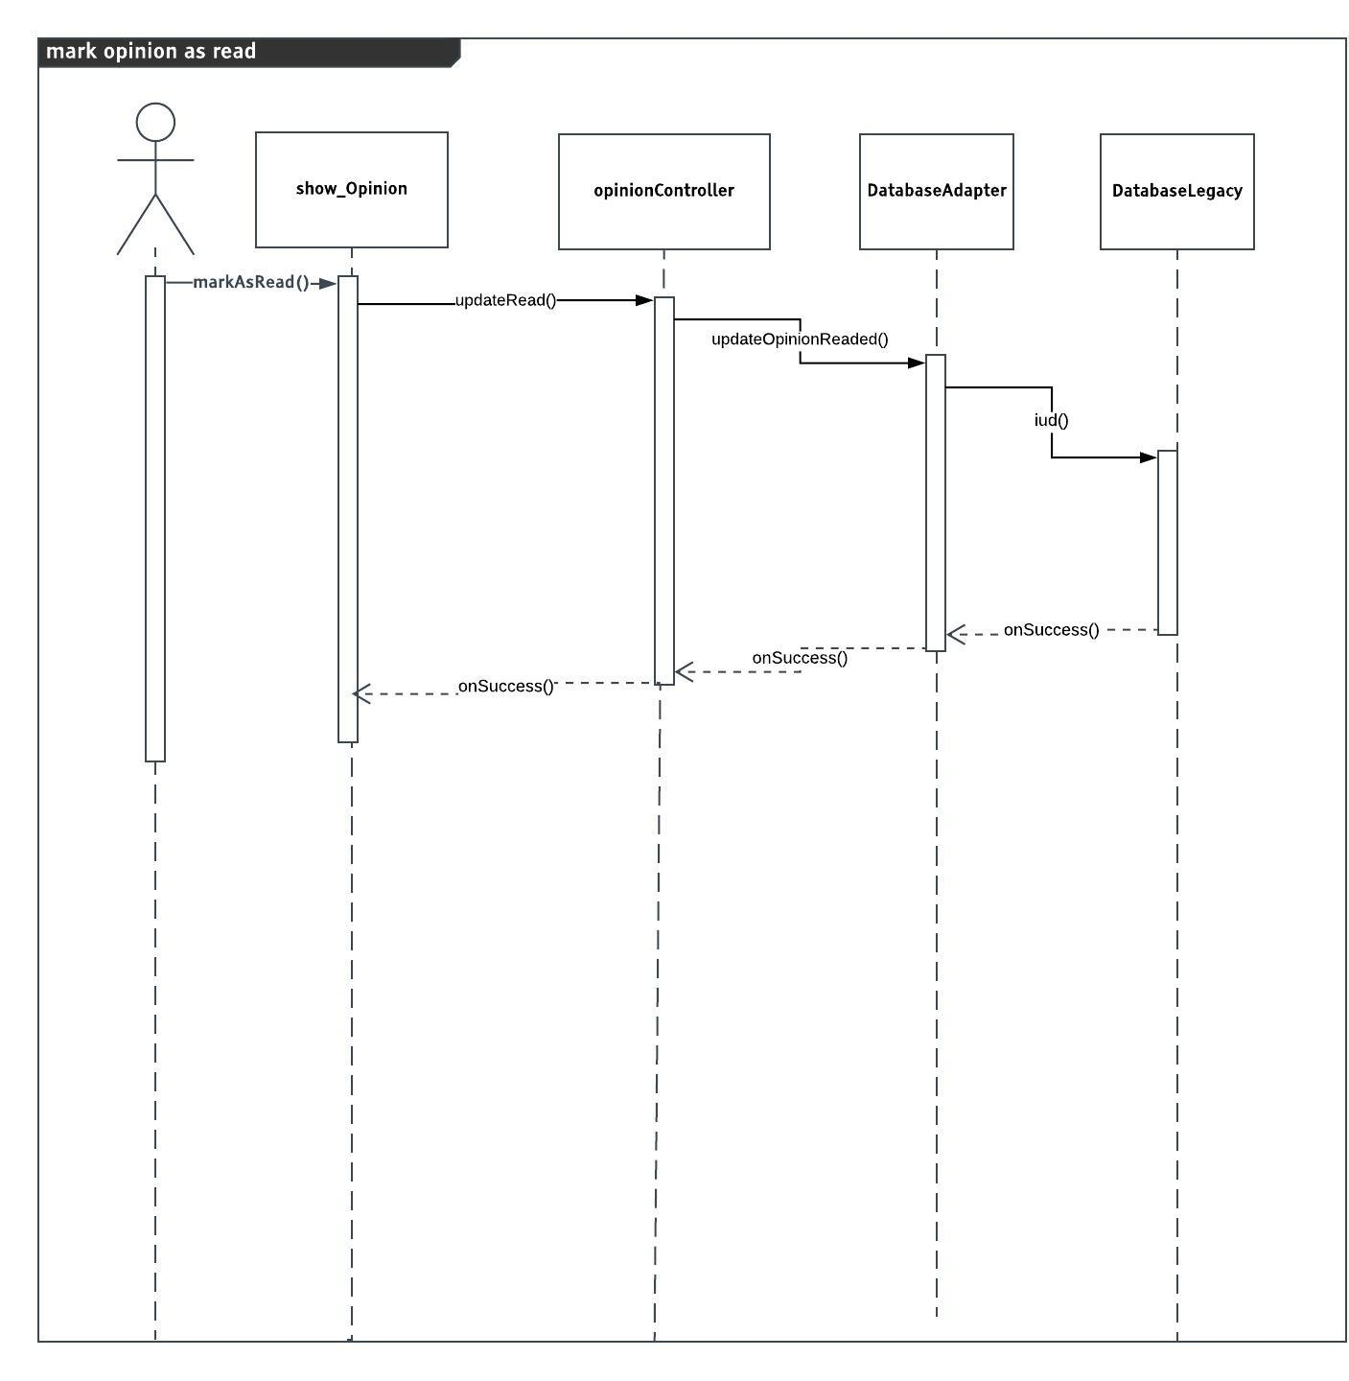
3.3.12 Make opinion as read

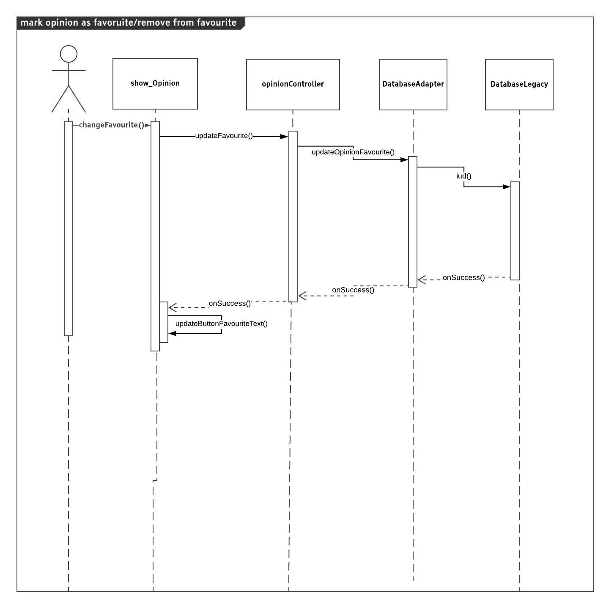
3.3.13 Put opinion as favorite or remove it from favorite opinions
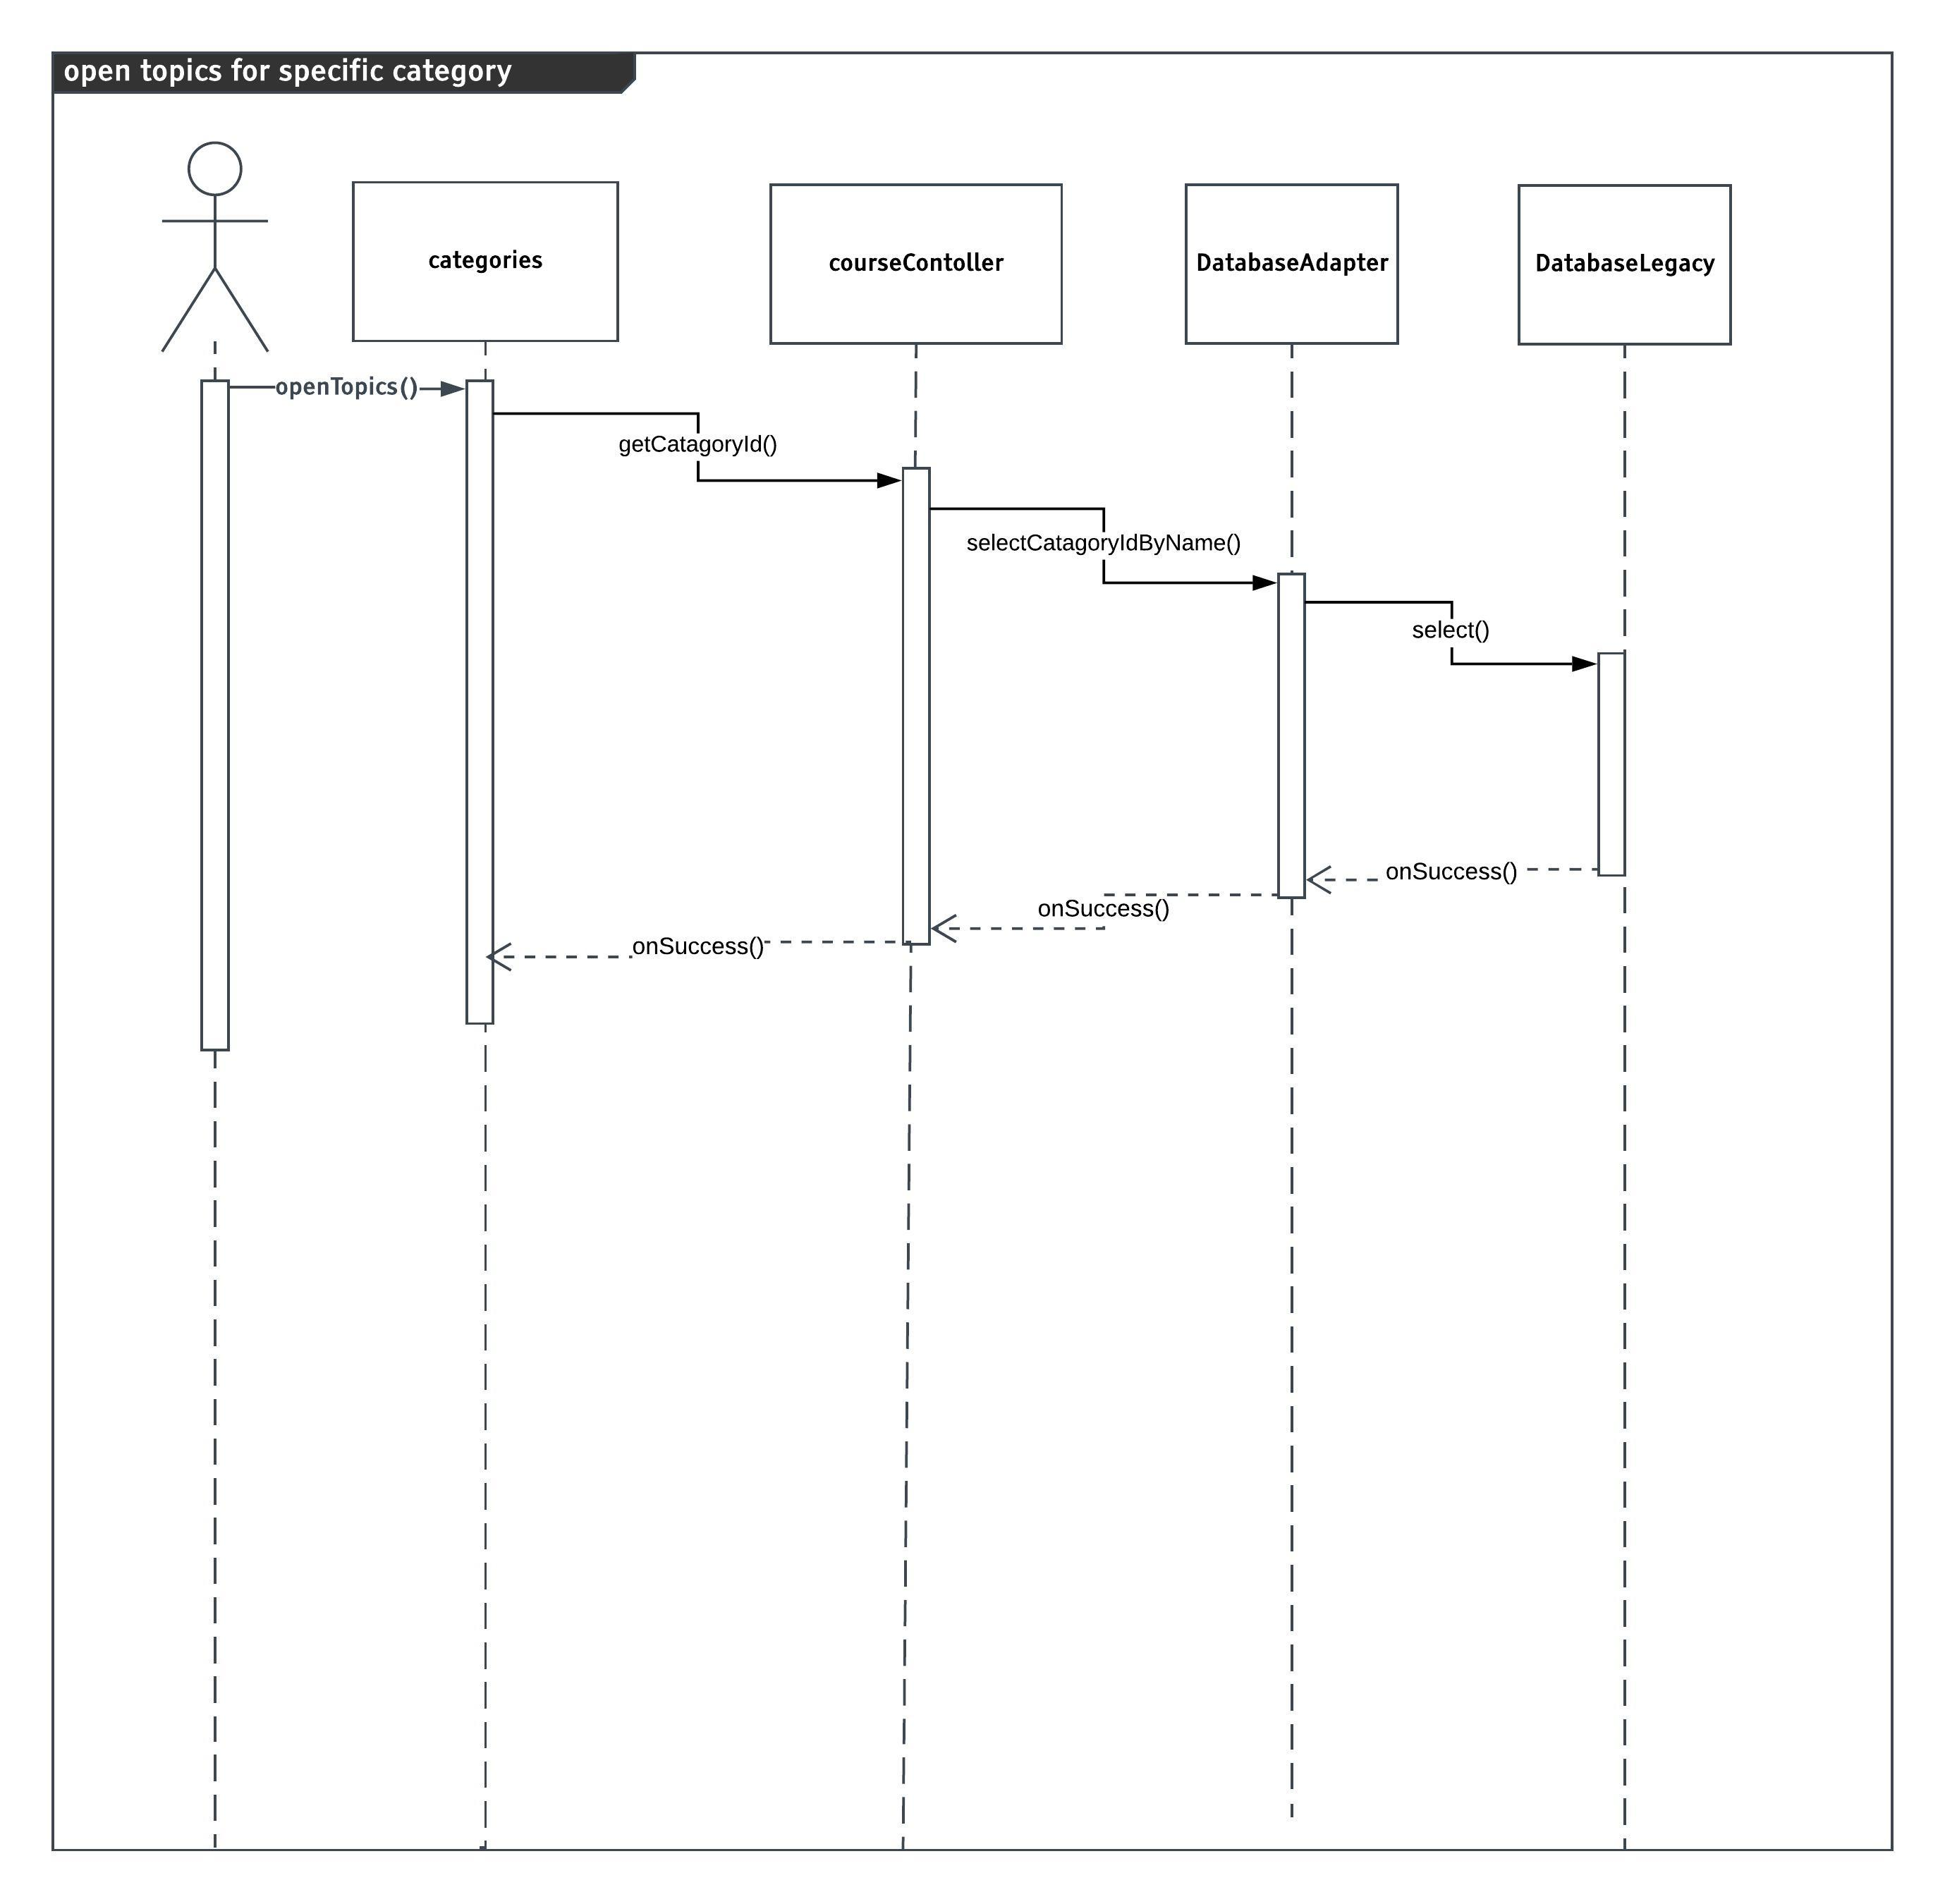
3.3.14 Open topics for specific category

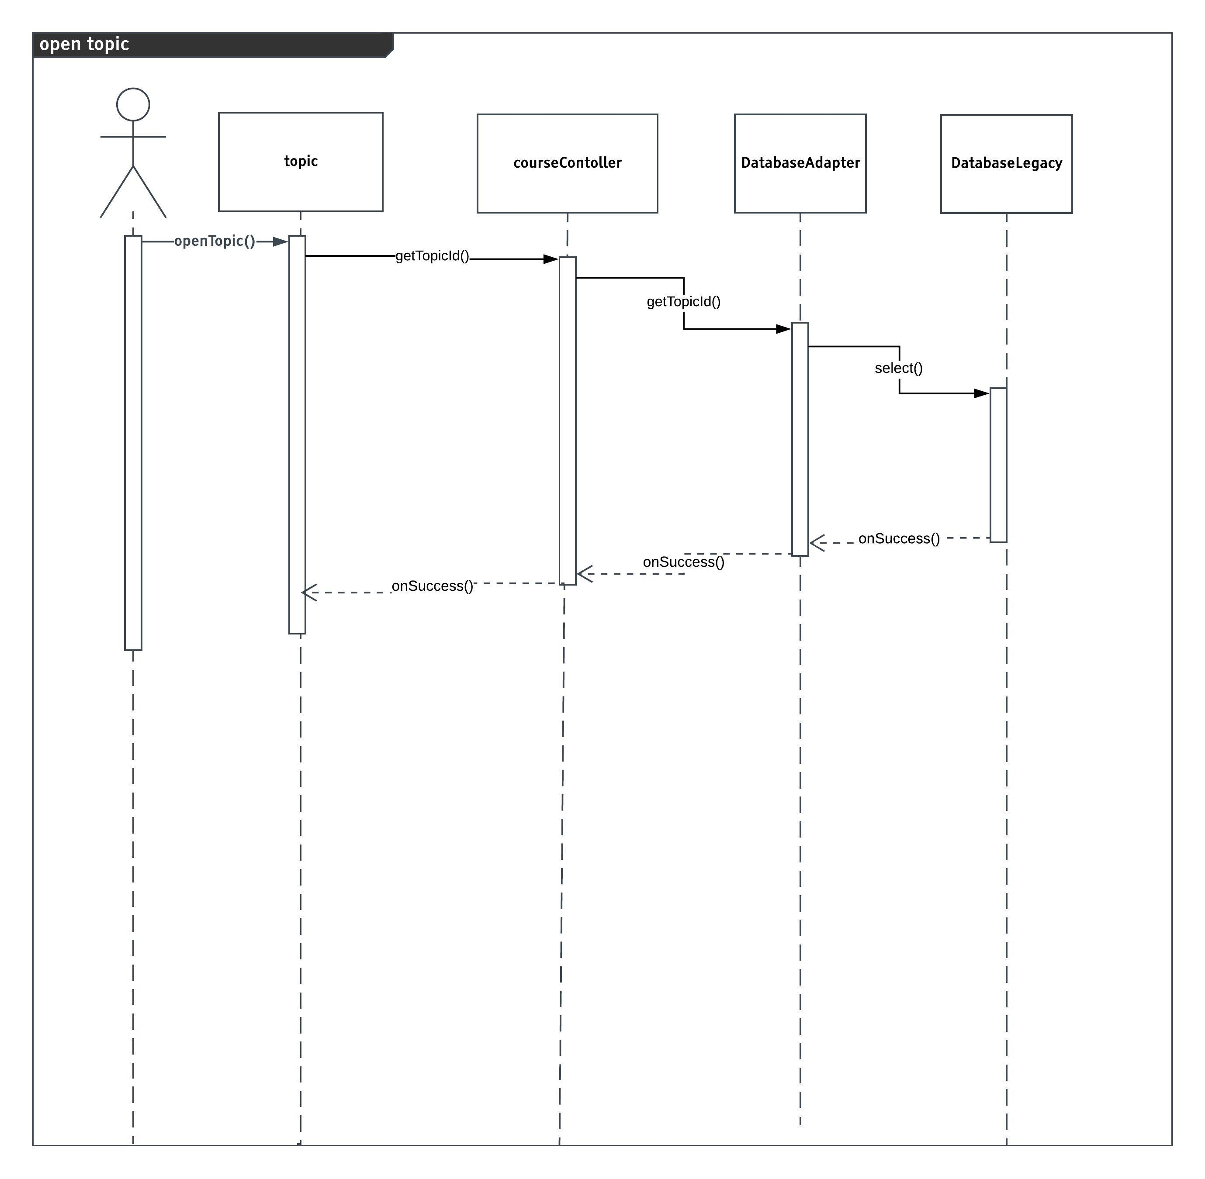
3.3.15 Open topic

Data Models

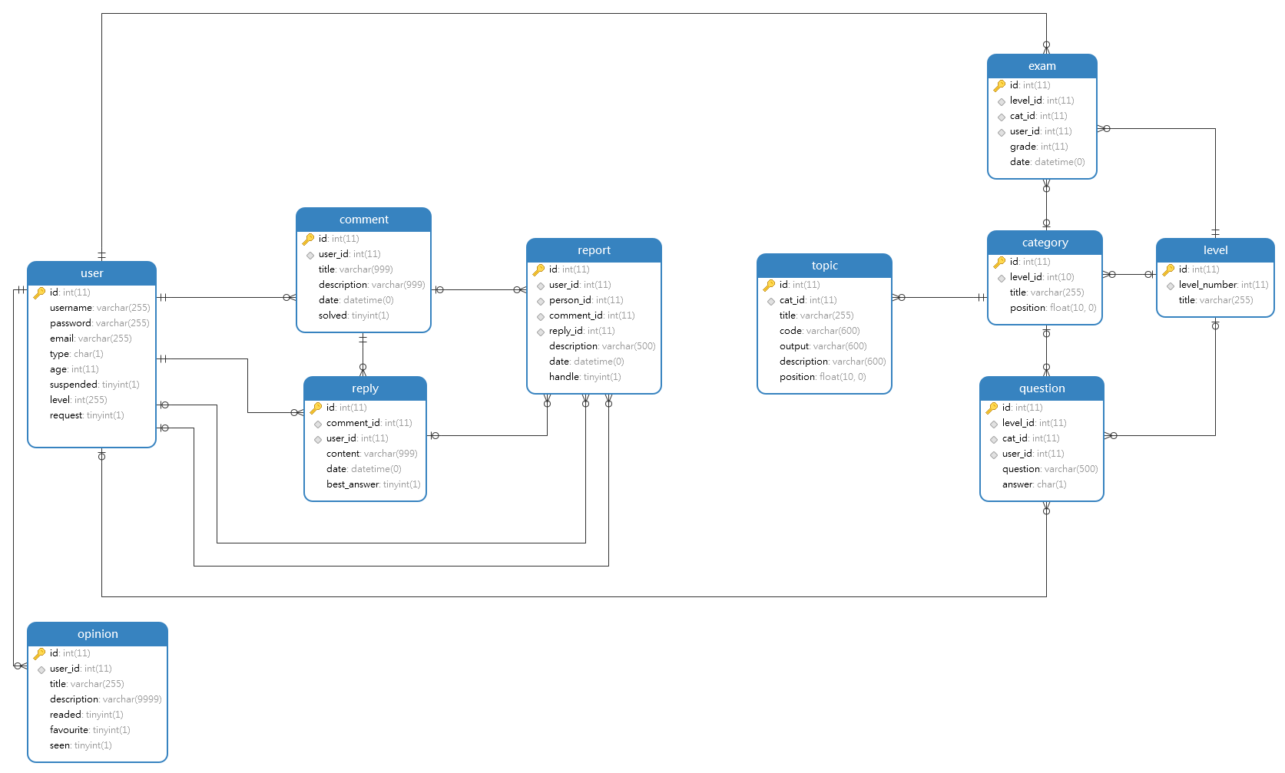 ER-Diagram

System Deployment
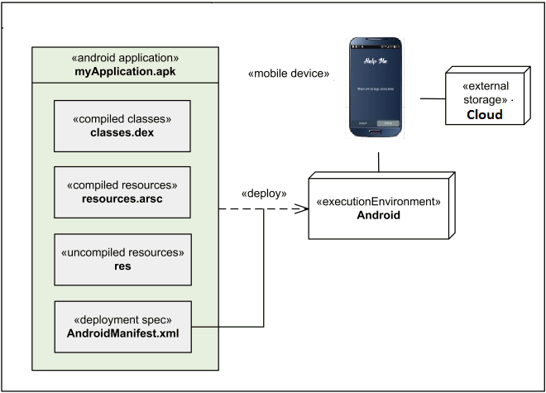

Traceability to Requirements
This table shows the relation among user stories in SRS document and Design Models diagrams
 | Interaction diagram
US-01 | 3.3.1
US-02 | -
US-03 | -
US-04 | -
US-05 | -
US-06 | 3.3.4 – 3.3.5 – 3.3.6
US-07 | -
US-08 | 3.3.1
US-09 | -
US-10 | -
US-11 | -
US-12 | -
US-13 | -
US-14 | -
US-15 | 3.3.14 – 3.3.15
US-16 | 3.3.4 – 3.3.5 – 3.3.6
US-17 | 3.3.2
US-18 | 3.3.7 – 3.3.8
US-19 | -
US-20 | 3.3.7 – 3.3.8
US-21 | 3.3.1 - 3.3.2
US-22 | 3.3.9
US-23 | 3.3.4 – 3.3.5 – 3.3.6
US-24 | 3.3.2
US-25 | 3.3.3
US-26 | -
US-27 | -

